My name is Arohan Agate and I plan on studying Computer Science, on a pre-law track, as part of the Interdisciplinary Honors Program at the University of Washington. In my free time, I enjoy debating, learning trivia, and playing basketball. As someone born and raised in Portland, Oregon, and currently lives in Bellevue, I've seen the impact of homelessness on our community. I started Nourish the Northwest in 2021 with the mission of donating home-cooked meals to local homeless shelters. Since then, we've donated over 500 meals while forming partnerships with some of the biggest shelters in the Greater Seattle area. Through my experiences, I've had the privilege of helping a core part of our community while also finding a place within.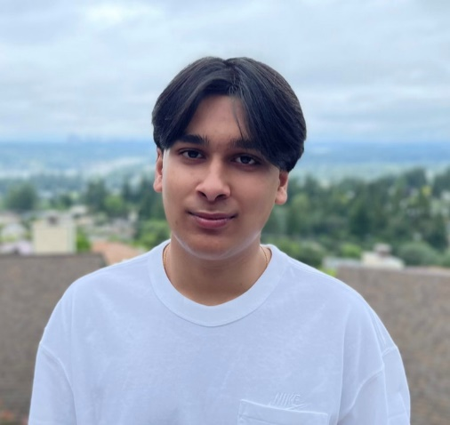
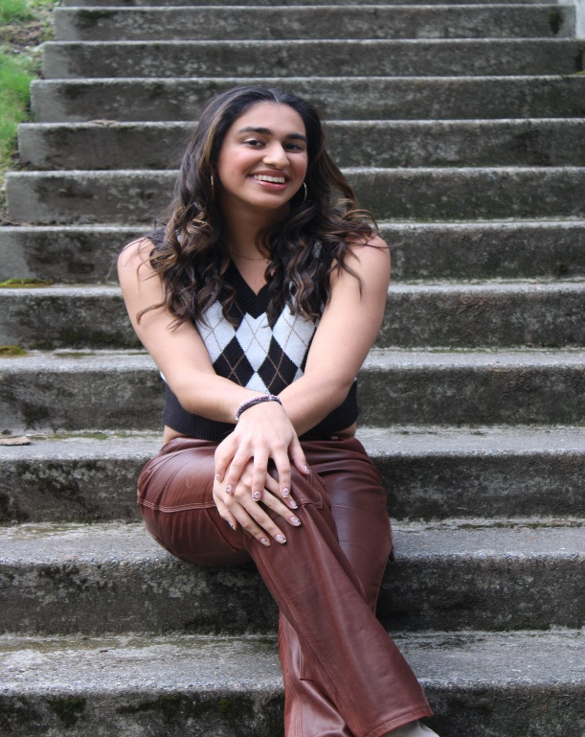
My name is Ammana Karmali and I am planning on studying Cell and Molecular Biology at Columbia University in the fall. I am an avid athlete - I’ve captained the Newport varsity soccer team and played on the varsity basketball team. Having spent much of my youth volunteering in my Ismaili religious community, service to others is a large part of my identity. In my free time I love to mentor youth as a camp counselor, basketball coach, American Sign Language club President, and as an English teacher to youth overseas in Afghanistan and Tajikistan. I have found my calling in helping those that are struggling with illness. I have worked as a Nursing Assistant at an Assisted living and Memory Care facility, I have lead fundraising drives for the Leukemia and Lymphoma Society, and I have volunteered at Swedish Hospital and Bloodworks Northwest. Mentoring youth and spending time with the elderly energize and inspire me. I hope to one day make a career out of my passions and become a clinical oncologist and educator.

